Project Development Phase
Performance Test

Date | 3 OCTOBER 2026
Team ID | SWTID-2026-9505
Project Name | Project - Implement Client Script & UI Policy (Incident) in ServiceNow
Maximum Marks

Model Performance Testing:
Project team shall fill the following information in model performance testing template.
S.No. | Parameter | Screenshot / Values
 | Data Rendered | Incident table records rendered in the ServiceNow list and form views (PDI), used to test the UI Policy and Client Scripts.  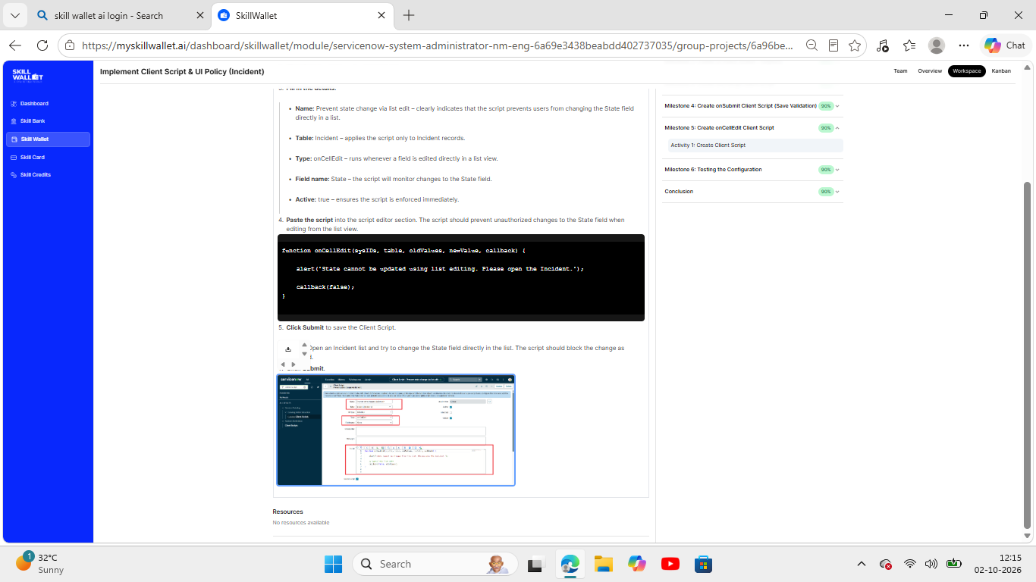
 | Data Preprocessing | Not applicable - no external dataset was imported or cleaned. The work uses existing Incident table records in ServiceNow.
3. | Utilization of Filters | Not applicable (no Tableau filters). Equivalent condition used: UI Policy "High Impact Control" runs only when Impact is 1 - High.  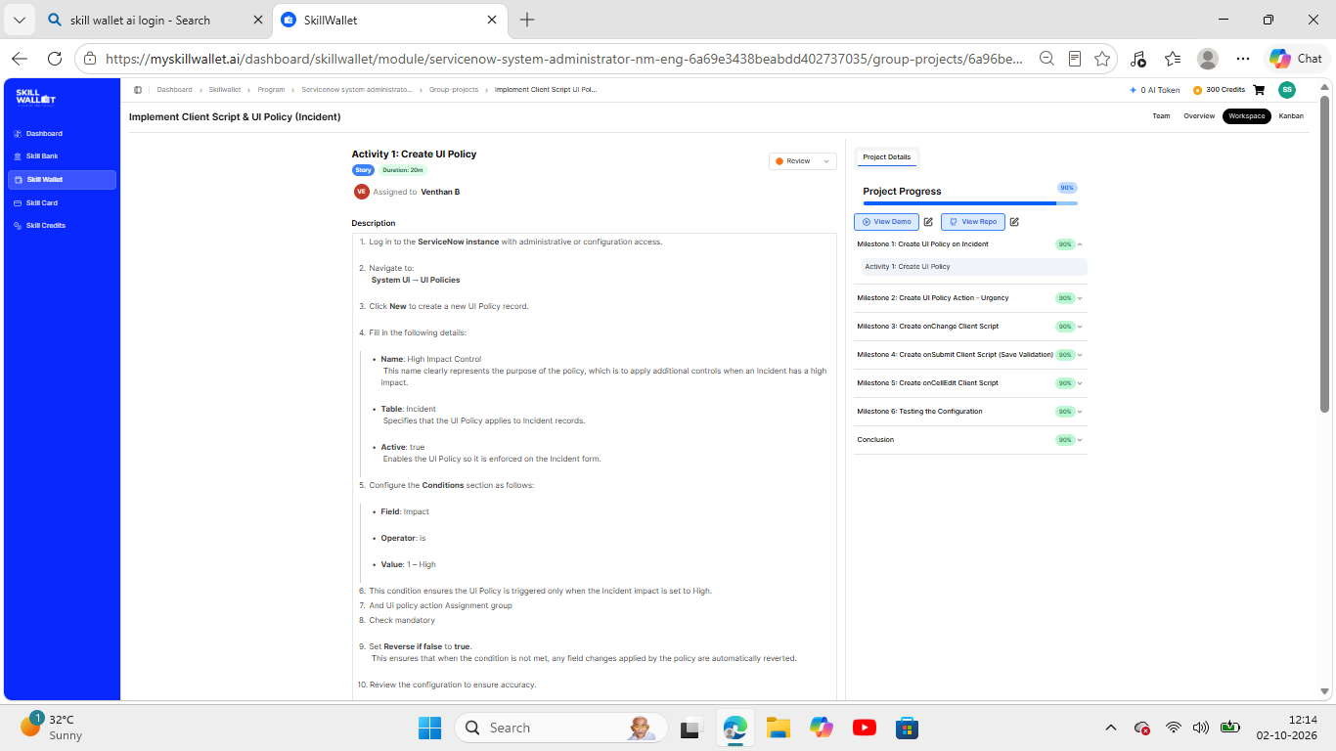
4. | Calculation fields Used | Not applicable (no calculated fields). Equivalent logic: onChange Client Script sets Urgency to 1 when Impact is High.  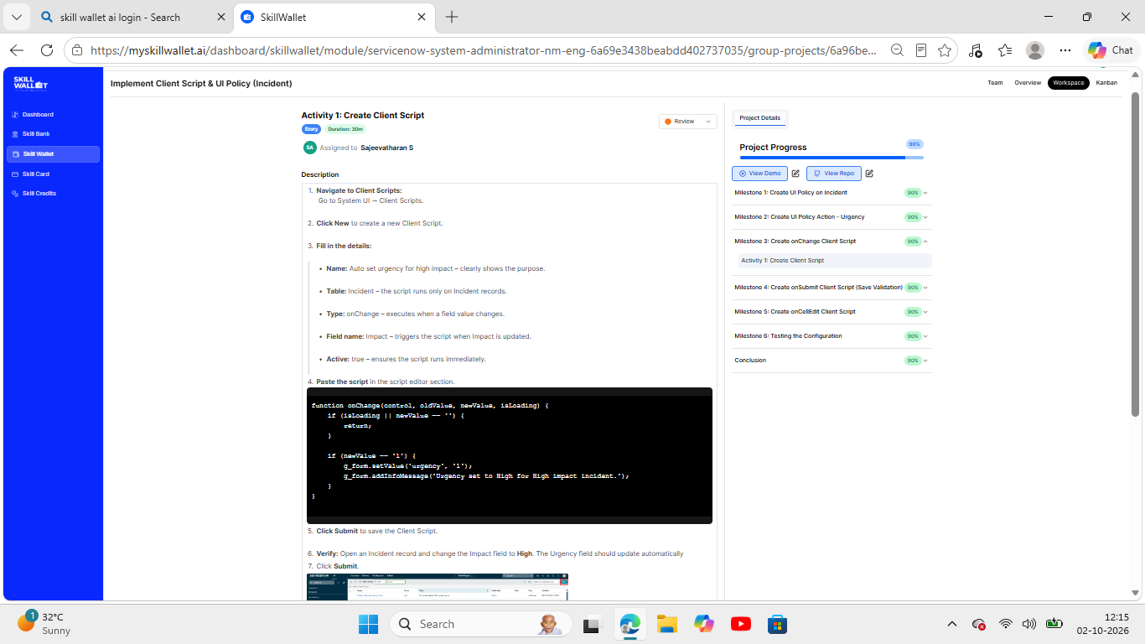
5. | Dashboard design | No of Visualizations / Graphs - 0 (not applicable - no dashboard in this project)
6 | Story Design | No of Visualizations / Graphs - 0 (not applicable - no story in this project)

